Power Mapping Sheet for Graduate Student Advocacy

What is Power Mapping?
Power mapping is a strategic planning tool that helps identify who has decision-making power on your issue, who influences them, and how you can effectively target your advocacy efforts. This process helps you understand the landscape of power and influence to create more effective campaigns.

Step 1: Define Your Specific Advocacy Goal
Your Advocacy Goal
Example: Protect F&A research funding rates at your institution
Write your specific, measurable goal here:

Step 2: Identify Key Decision Makers
Decision Maker | Position/Role | Power Level (1-10) | Stance on Issue (Ally, Neutral, Opposed) | Notes
Example: Senator Jones | Senate Appropriations Committee | 8 | Neutral | Has history of supporting research funding

Step 3: Map Primary and Secondary Targets
Primary Targets (Direct Decision Makers)
Name | Institution | Contact Information | Staff Contact | Priority Level

Secondary Targets (Influencers of Decision Makers)
Name | Relationship to Decision Maker | Stance on Issue | Access Strategy
Example: University President | Regular meetings with Rep. Smith | Supportive | Request meeting to discuss F&A impacts

Step 4: Visual Power Map
Create a visual representation by placing decision-makers on a grid:
· X-axis: Position your issue (Opposed to Supportive)
· Y-axis: Level of influence/power (Low to High)
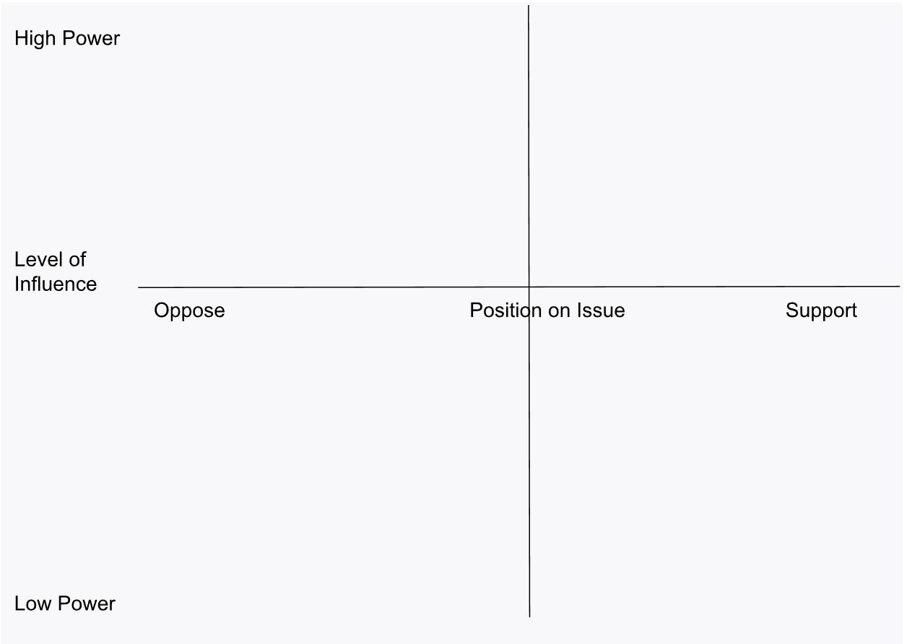

Step 5: Identify Pathways of Influence
Decision Maker | Who/What Influences Them (Examples: Donors, constituents, media, data/research, personal stories) | Your Connection | Action Plan

Step 6: Resource Assessment
Resource | Available? | How to Obtain/Utilize
Student stories/testimonials
Research data on impacts
Coalition partners
Media contacts
Funding for advocacy

Step 7: Action Plan Timeline
Timeline | Target | Action | Person Responsible | Success Metrics
Immediate (1-2 days)
Short-term (1-2 weeks)
Medium-term (1-2 months)
Long-term (3+ months)

Campus-Specific Power Mapping  For your specific institution, identify:  - Key Campus Decision Makers:  - Administration officials (President, Provost, etc.)  - Faculty governance representatives  - Board of Trustees/Regents members  - Institutional Policies Affecting Your Issue:  - Current policies  - Upcoming policy reviews/changes  - Historical positions on similar issues  - Campus Allies:  - Faculty supporters  - Staff advocates  - Other student organizations  - Alumni networks  - Communication Channels:  - Campus media  - Administrative meetings  - Public forums  - Social media platforms | Advocacy Tools Checklist  - Use the "Five Calls" app to contact representatives  - Utilize the UC Advocacy Network or similar platforms  - Schedule in-person meetings with decision-makers  - Prepare personal stories and data  - Coordinate with coalition partners  - Develop media strategy  - Create materials (fact sheets, talking points)  - Plan follow-up and tracking of outcomes  Remember that power mapping is a dynamic process. Update your map regularly as the landscape changes and your advocacy progresses!

